Ideation Phase
Define the Problem Statements

Date | 31 January 2025
Team ID
Project Name | Ecommerce
Maximum Marks | 2 Marks

Customer Problem Statement Template:
To understand the key challenges customers face while shopping online, this template helps clearly capture their needs, expectations, and frustrations. It reveals what users want to achieve, the barriers preventing them from completing purchases smoothly, and the reasons behind those obstacles. These insights guide us in designing a faster, safer, and more enjoyable online shopping experience. Ultimately, the template supports the development of solutions that directly address customer pain points and improve overall satisfaction.

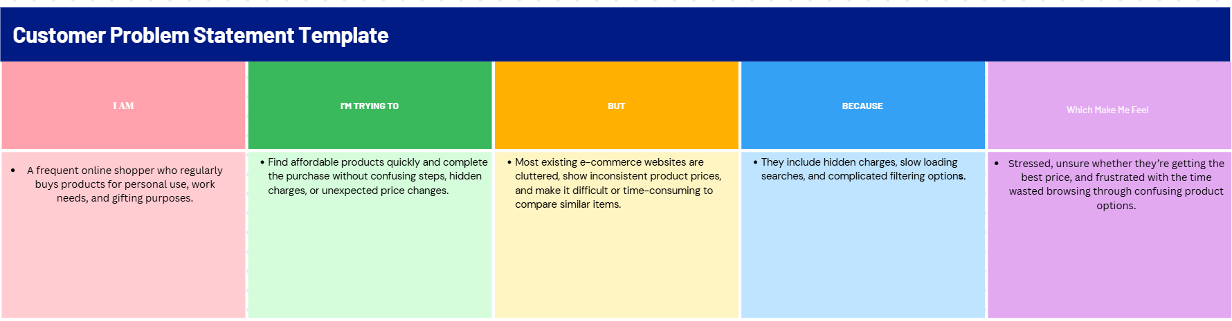

c | I am (Customer) | I’m trying to | But | Because | Which makes me feel
PS-1 | frequent online shopper | find the cheapest and best products | prices vary across different sellers and platforms | hidden fees, inconsistent pricing, and unreliable discounts | confused and worried about overspending
PS-2 |  | purchase items quickly without delays | websites take too long to load product results | too many ads, irrelevant product suggestions, and slow search filters | stressed and frustrated when buying urgently
  busy professional

